**TOPICS: Allowed Time:** 60 Minutes

**Instructions: Total Marks:** 25

1. Gossips are not allowed.
2. Teacher assistants are for your help, so be nice with them. Respect them as they are teaching you. Raise your hands if you have some problem and need help from TA. Avoid calling them by raising your voice and disturbing the environment of Lab.
3. TA may deduct your marks for any kind of ill-discipline or misconduct from your side.
4. Evaluation will be considered final and you cannot debate for the marks. So, focus on performing the tasks when the time is given to you.
5. Paste the query as well as result table screenshot as a result of each task

**Task 01: _________________________ ___________ (25 Marks)**

1. Maximum Salary Difference Between Employees in "Veteran" (Hired before 1985) and "Newcomer" (Hired after 1985) Categories

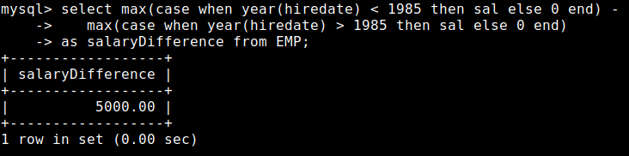

1. Average Length of Employee Names by Department

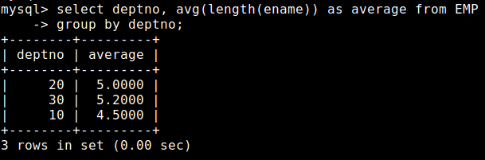

1. Find the Employee with the Longest Name in Each Department

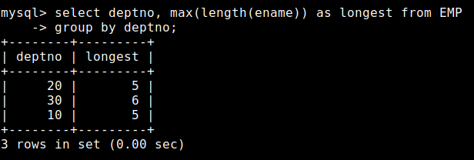

1. Count of Employees with "High" Income (Salary > 2000) by Department and Format Employee Names in Uppercase

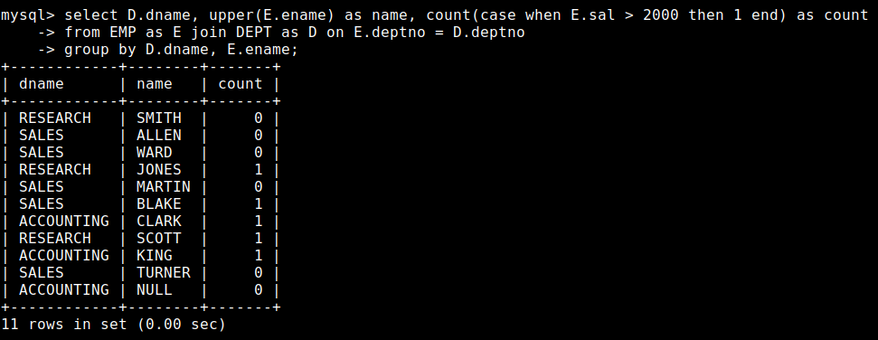

1. Calculate Total Salary and Average Commission by Department for Employees with Commission

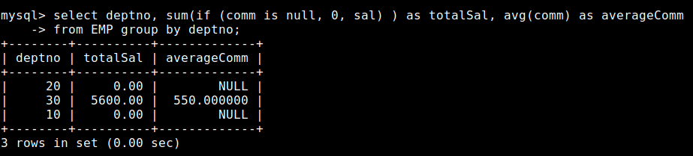

1. Determine the Number of Characters in the Longest Job Title Across All Departments

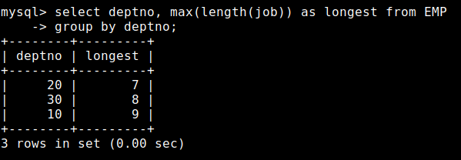

1. Calculate Average Salary by Department and Grade

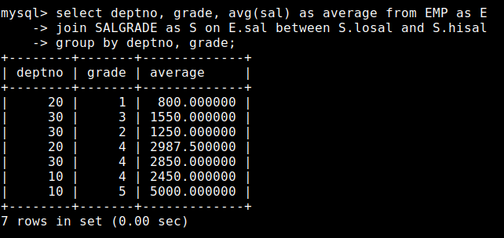

1. List Departments with Total Salary Above 5000 and Average Grade Below 4

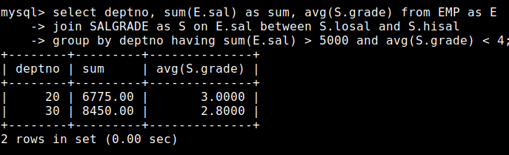

1. List All Grades and Departments with No Employees in That Grade

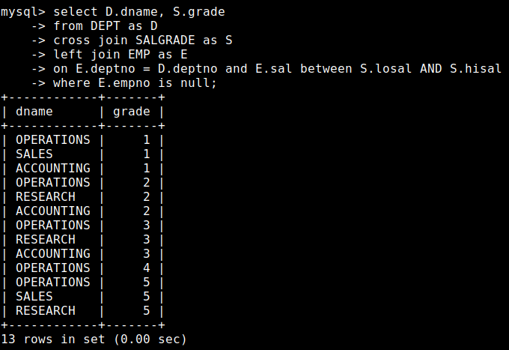

1. Show Departments Where at Least 50% of Employees Are in Grade 3 or Above

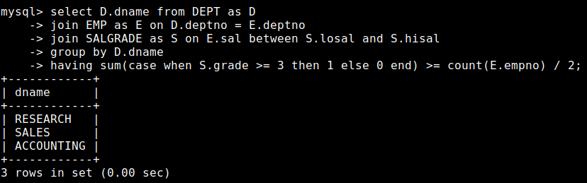

1. Find the Average Salary Increase Needed for Employees to Reach the Next Grade

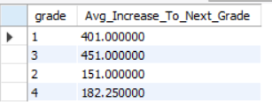

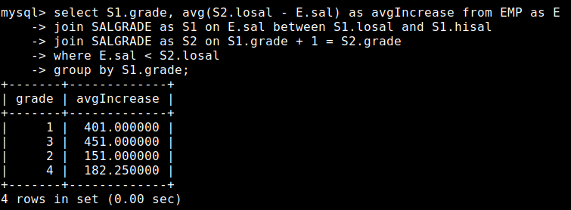

1. Display each employee’s name, job title, and department name. If an employee is in department 10, add "(Admin)" next to their job title. If the employee has no department, show "Not Assigned" in place of the department name.

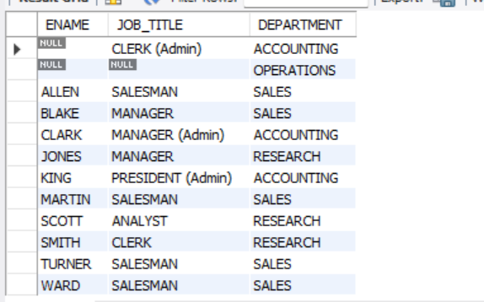

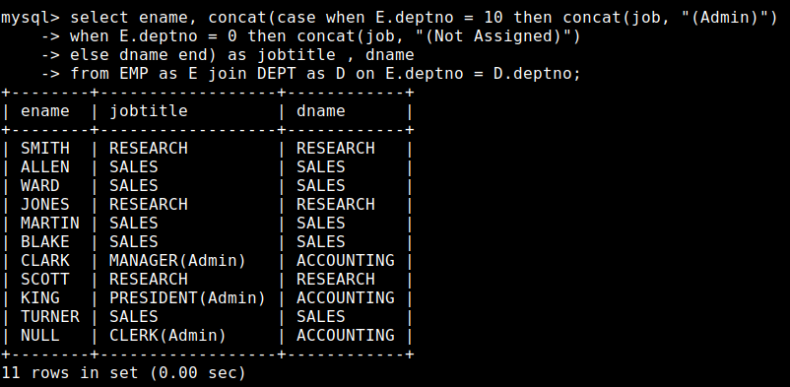

1. Show the average salary by department for departments with an average salary above 2000. Include departments with no employees, showing NULL as the average salary for them.

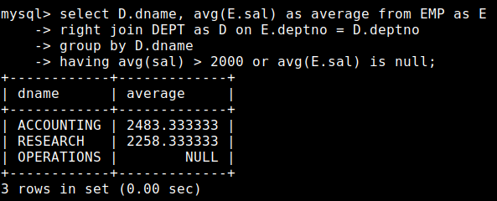

1. Fetch a list of unique job titles and their respective salary grades. If the salary grade is NULL, mark it as "Not Graded".

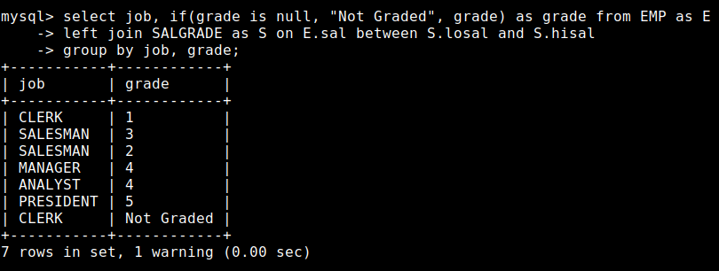

1. Get a distinct list of departments and the total number of employees in each, but only for departments with more than two employees.

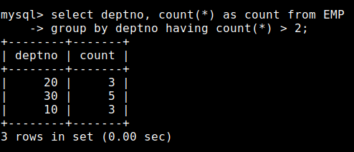

1. Show the number of employees hired each year. Include only years with more than three employees hired.

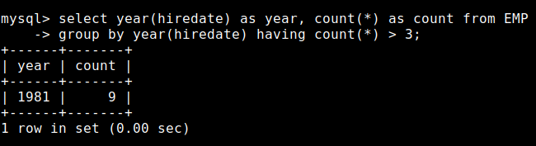

1. For each department, count how many employees are categorized as "Senior" (salary above 2000) or "Junior" (salary 2000 or below).

